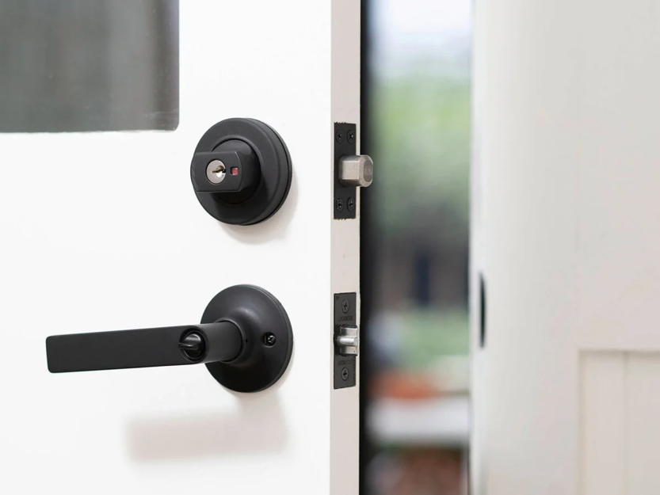
Deadbolt Lock
- Where you may find it: Front doors of houses or apartments
Explanation:
A deadbolt is a strong door lock that cannot be opened easily without a key. It provides high security for doors.
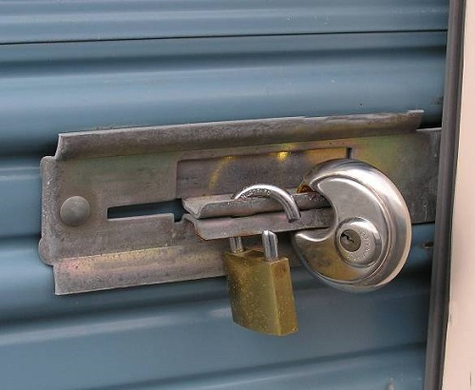
Padlock
- Where you may find it: Gates, lockers, fences, storage units
Explanation:
A padlock is a portable lock used to secure items like gates or lockers.

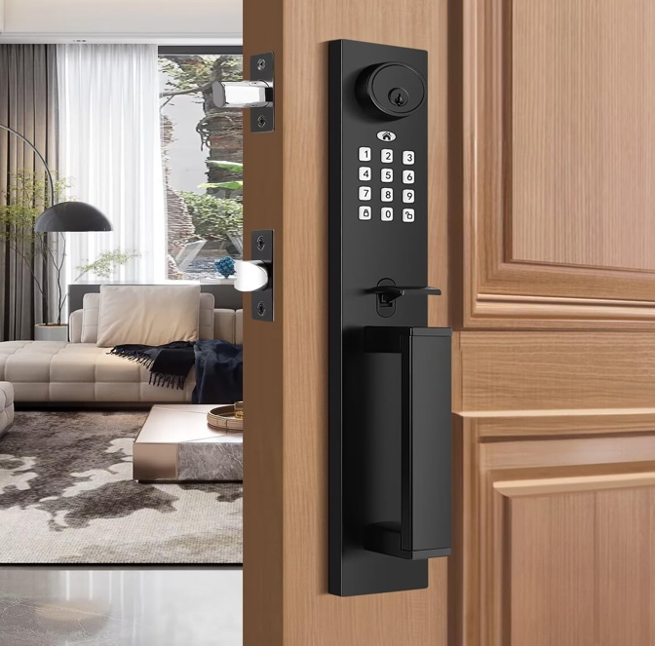
- Smart Lock
Security Concept: Electronic access control
Simple Explanation:
Smart locks allow doors to be opened using a code, phone, or fingerprint instead of a key.
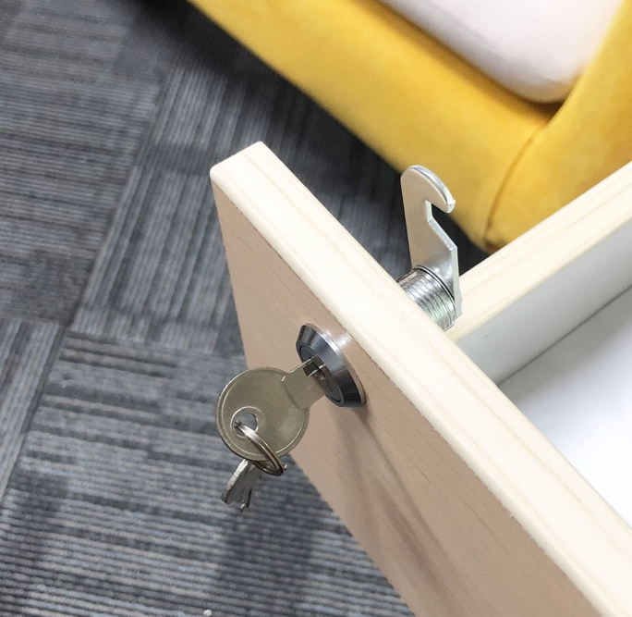
4. Cam Lock
here you may find it: Cabinets, mailboxes, lockers
Explanation:
Cam locks secure small storage spaces like drawers or cabinets.

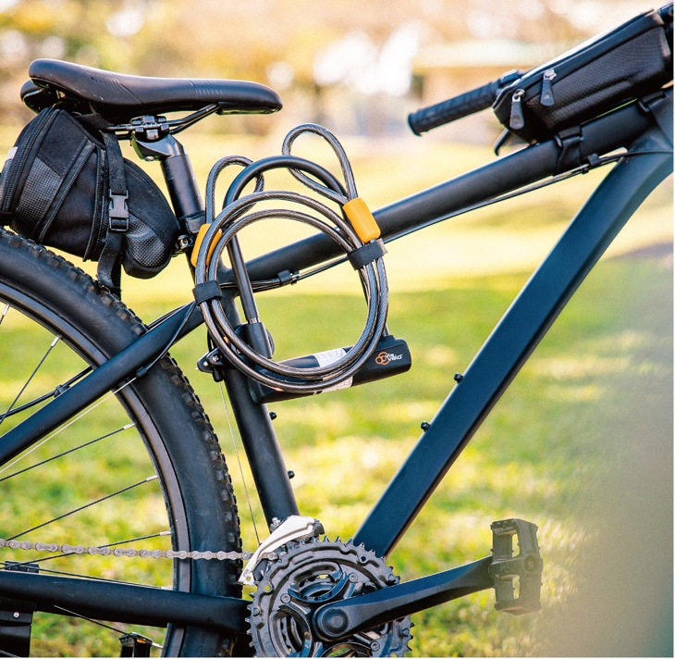
5. U-Lock (Bike Lock)
Where you may find it: Bike racks on campus or streets
Explanation:
A U-lock is a strong metal lock used to protect bicycles from theft.
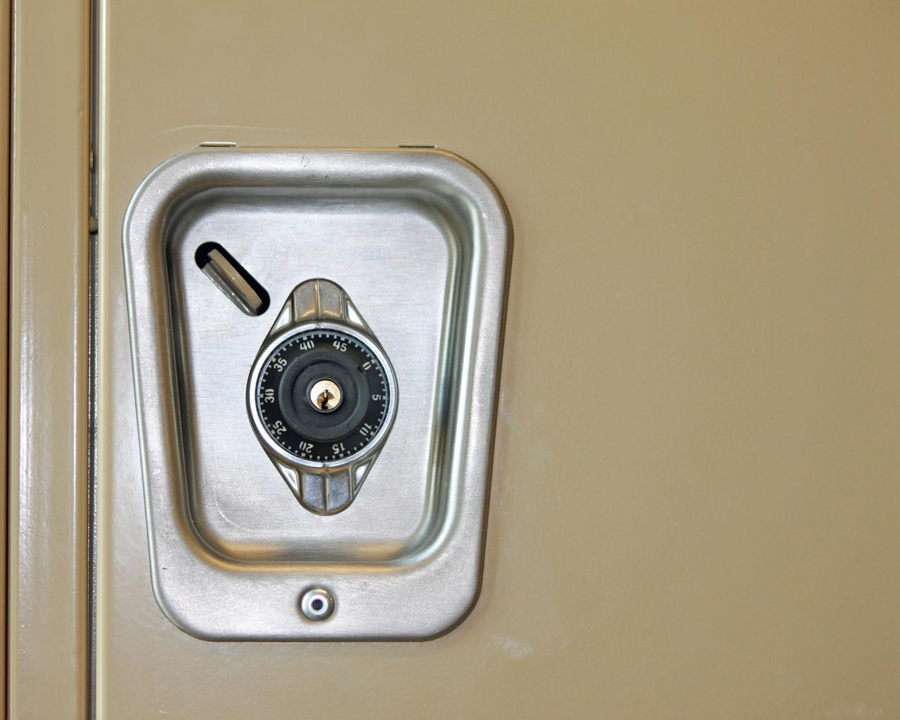
6. Combination Lock
Where you may find it: Gym lockers, school lockers
Explanation:
This lock opens using a number code instead of a key.
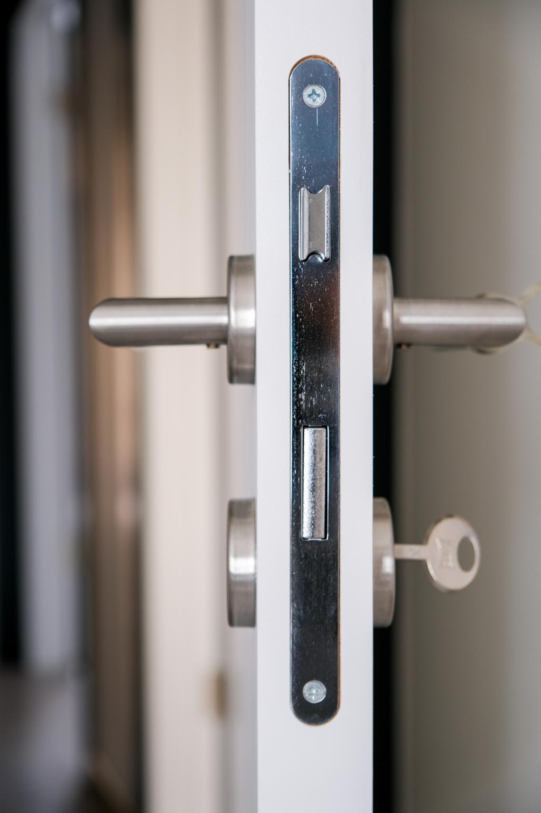
7. Knob Lock
Where you may find it: Interior doors in homes or offices
Explanation:
Knob locks are common locks where the keyhole is inside the door knob.
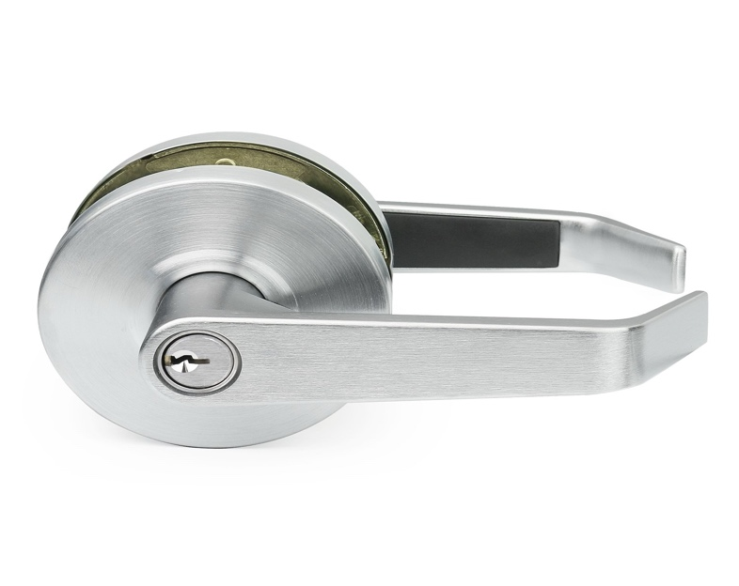
8. Lever Handle Lock
Where you may find it: Offices, schools, hospitals
Explanation:
This lock uses a lever handle instead of a knob, making it easier to open.

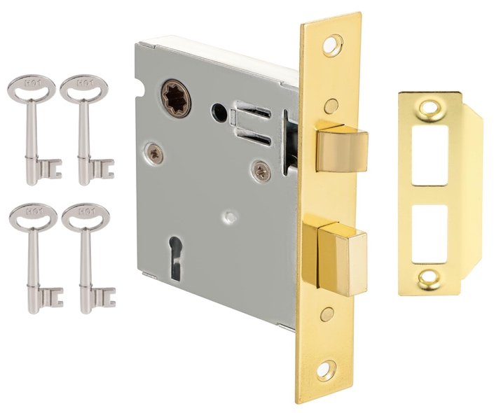
9. Mortise Lock
Where you may find it: Older buildings or commercial doors
Explanation:
A mortise lock is installed inside the door, making it stronger and more secure.
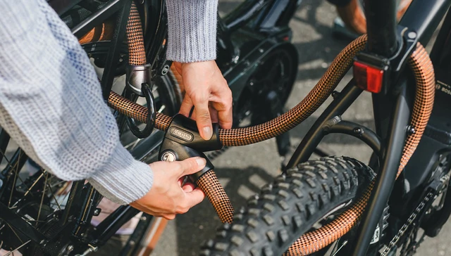
10. Cable Lock
Where you may find it: Bikes, luggage, helmets
Explanation:
Cable locks use a flexible steel cable to secure items.

